PROJECT DOCUMENTATION

- Title :- Crop Recommendation System using Data Analysis and Feature Engineering .

Submitted By :- Sujal Sudhakar Salvi .

Course :- Data Analytics .

Submitted To :- Prajakta Tayde .

- Introduction :-
Agriculture plays an important role in our daily life. Choosing the right crop based on soil and weather conditions helps farmers increase productivity and reduce loss. This project focuses on analyzing agricultural data by using feature engineering techniques.
- Objectives of the Project :-
- To study soil and environmental conditions
- To analyze crop-related data
- To apply feature engineering techniques
- To prepare data for machine learning
- To improve crop prediction accuracy

- Dataset Description :-
Dataset Name :- Crop Recommendation Dataset
Description :- The dataset contains information related to soil nutrients and environmental conditions. Based on these values, the most suitable crop is identified.

- Column Description :-

        - N (Nitrogen) :- This column represents the amount of nitrogen present in the soil. Nitrogen is essential for plant growth and helps in the development of leaves.

        - P (Phosphorus) :- This column shows the phosphorus content in the soil. Phosphorus supports root development and improves crop maturity.

        - K (Potassium) :- This column indicates the potassium level in the soil. Potassium helps plants resist diseases and improves overall plant strength

        - Temperature :- This column represents the environmental temperature measured in degrees Celsius. Temperature affects the growth rate and health of crops.

        - Humidity :- This column shows the relative humidity percentage in the air. Humidity influences plant water retention and transpiration.

        - PH :- This column indicates the pH value of the soil, which shows whether the soil is acidic, neutral, or alkaline. Soil pH affects nutrient absorption by plants.

        - Rainfall :- This column represents the amount of rainfall received, measured in millimeters. Rainfall is an important factor for crop water availability.

        - Label (Crop) :- This column contains the name of the crop that grows best under the given soil and weather conditions.

- Dataset Analysis :-

- Data Visualization: Distribution of Total Nutrients :-

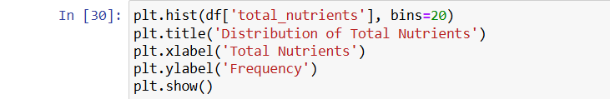

Explanation :- This figure shows a histogram representing the distribution of total nutrient values in the dataset. The total nutrients are calculated by summing Nitrogen (N), Phosphorus (P), and Potassium (K) for each soil sample. This graph helps in understanding how overall soil fertility is spread across the data and identifies the common nutrient ranges present. Such visualization supports the data preprocessing and feature engineering process by validating the importance of combining individual nutrient values into a single feature.

- Feature Engineering: N_P_ratio :-

Explanation :- A new feature called N_P_ratio is created using the existing soil nutrient columns. This feature is calculated by dividing the Nitrogen (N) value by the Phosphorus (P) value for each record in the dataset. Instead of using Nitrogen and Phosphorus separately, this ratio helps in understanding the balance between these two important nutrients in the soil. The value 1 is added to the Phosphorus column to avoid division by zero. This ensures that the calculation does not produce errors and the program runs smoothly for all data points.

- Feature Engineering: P_K_ratio

Explanation :- A new feature named P_K_ratio is created by dividing the Phosphorus (P) value by the Potassium (K) value for each record in the dataset. This feature helps in understanding the relationship and balance between Phosphorus and Potassium nutrients present in the soil. Phosphorus is important for root development, flowering, and seed formation, while Potassium helps plants resist diseases and improves overall plant strength. For proper crop growth, both nutrients must be available in suitable proportions. By calculating the Phosphorus to Potassium ratio, the dataset captures this nutrient relationship more effectively than using individual values alone.

- Feature Engineering: N_K_ratio:-

Explanation :- A new feature called N_K_ratio is created by dividing the Nitrogen (N) value by the Potassium (K) value for each record in the dataset. This feature helps in understanding the balance between Nitrogen and Potassium nutrients present in the soil. Nitrogen supports leaf growth and overall plant development, while Potassium improves plant strength and resistance to diseases. For crops to grow properly, these nutrients must be present in the right proportion. The Nitrogen to Potassium ratio provides useful insight into soil fertility and nutrient balance.

- Feature Engineering : total_nutrients :-

Explanation :- A new feature called total_nutrients is created by adding the values of Nitrogen (N), Phosphorus (P), and Potassium (K) for each record in the dataset. These three nutrients are the main components required for healthy crop growth, and together they represent the overall fertility of the soil. Instead of analyzing each nutrient separately, this feature provides a single value that summarizes the combined nutrient level of the soil. This makes it easier to understand whether the soil is nutrient-rich or nutrient-poor.

- Feature Engineering: Temperature–Humidity :-

Explanation :- A new feature named temp_humidity is created by multiplying the temperature and humidity values for each record in the dataset. Temperature and humidity together play an important role in crop growth, as they directly affect plant health, water loss, and overall development. Instead of using temperature and humidity as separate features, combining them helps in understanding their joint effect on crops. Some crops grow well only when both temperature and humidity are within a suitable range, and this combined feature captures that relationship.

- Distribution of Total Nutrients :-

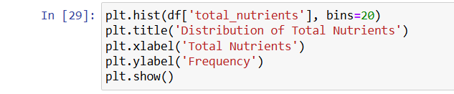

Explanation :- This figure shows a histogram representing the distribution of total soil nutrient values in the dataset. The total nutrients are calculated by combining Nitrogen (N), Phosphorus (P), and Potassium (K) for each soil sample. This visualization helps in understanding how soil fertility varies across different observations. By analyzing the frequency of nutrient values, it becomes easier to identify common nutrient ranges present in the dataset. This graph supports the feature engineering process by validating the creation of a combined nutrient feature, which can be useful for improving crop recommendation accuracy.

- Distribution of Rainfall :-

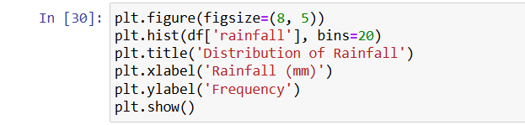

Explanation :- This figure represents a histogram showing the distribution of rainfall values present in the dataset. Rainfall is an important climatic factor that directly affects crop growth. This visualization helps in understanding the range and frequency of rainfall conditions under which different crops are recommended. Such analysis supports better understanding of environmental patterns before applying feature engineering and machine learning techniques.

- Conclusion :-

In this project, agricultural data was analyzed using feature engineering techniques to improve the understanding of soil and environmental conditions. New features were created to represent nutrient balance and weather interactions, which help in preparing the data for machine learning models. This analysis supports better crop recommendation and decision-making for agricultural planning.

